**WATER**

By Professor Shakhashiri

[*www.scifun.org*](http://www.scifun.org)*, Revised January 2011*

*(Portions of article removed and altered by Mr. Smith!)*

***Before you start reading, it is recommended you look over the questions you have to answer. They are at the end of this article. You can type your answers under the questions and print it out. If you write your answers, you MUST also write out the questions.***

Water covers about 70% of Earth’s surface, makes up about 70% of your mass, and is essential for life. It is the only substance that exists naturally on Earth in all three physical states of matter—gas, liquid, and solid—and it is always on the move among them. The Earth has oceans of liquid water and polar regions covered by solid water. Energy from the sun is absorbed by liquid water in oceans, lakes, and rivers and gains enough energy for some of it to evaporate and enter the atmosphere as an invisible gas, water vapor. As the water vapor rises in the atmosphere it cools and condenses into tiny liquid droplets that scatter light and become visible as clouds. Under the proper conditions, these droplets further combine and become heavy enough to precipitate (fall out) as drops of liquid or, or if the air is cold enough, flakes of solid, thus returning to the surface of the Earth to continue this cycle of water between its condensed and vapor phases.

Pure water is colorless, odorless, and tasteless and so common that you probably never think about how unique it is and how essential to life. Most plants and animals contain more than 60% water by volume. Without water, life would not have evolved on Earth, and it is the presence of water on Mars and some moons of Jupiter and Saturn that causes us to speculate about past or present life there as well.

Water has a number of unique chemical and physical properties that make it essential for life. One such property is familiar to everyone: solid water floats on liquid water. Almost all liquids contract when they get colder and reach a maximum density when they solidify. Water is different. As water cools, it contracts until it reaches 4 C, then it expands until it freezes at 0 C. Ice is less dense than water which allows ice cubes to float in a soft drink, icebergs to float in the ocean, and ponds and lakes to freeze from the top down so that aquatic plants and animals can survive in the unfrozen liquid below.

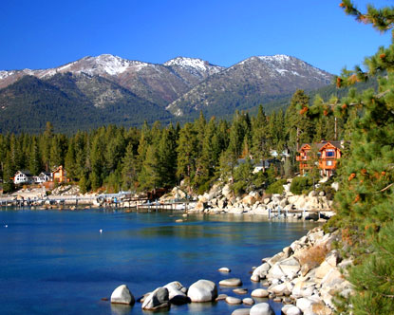It takes more energy to raise the temperature of one gram of water by 1 degree Celsius than any other liquid. Water must absorb a lot of heat energy to raise its temperature. Water can absorb large amounts of heat energy before it begins to get hot. Similarly, as water cools, it releases a great deal of heat. The high specific heat of water is responsible for the ocean’s ability to act as a thermal reservoir that moderates swings in the Earth’s temperature from day to night and from winter to summer, and this makes the planet suitable for its diverse inhabitants.

With water covering more than two-thirds of the Earth’s surface, it is hard to imagine that it is a scarce resource. The problem is that less than 1% of the water on the planet is readily available for drinking or for most agriculture. Most of the water on Earth, 97%, is salt water stored in the oceans; only 3% is freshwater. Of all of the freshwater on Earth, 68% is locked up in the icecaps of Antarctica and Greenland, 30% is in the ground, and only 0.3% is contained in surface waters such as lakes and rivers. (About 22% of all surface water is in the Great Lakes.) Over one billion people lack access to safe drinking water worldwide.

Solutions to the water scarcity problem include collection and storage of precipitation and desalinization of seawater. Since precipitation is dispersed over large areas, the cost to build the collection areas and storage is very high. Desalinization of seawater, or removing salt from water, is one possible way to help out the situation. Desalinized water, at about 0.5 cents per gallon is three to five times more expensive than water from freshwater sources. For comparison, bottled water from the supermarket (often no more than tap water in a plastic bottle) costs 2 to 5 dollars per gallon, or 400 to 1000 times as much as desalinized water. Bottled water is about a $10 billion industry in the United States.

Questions:

1. Water exists in what 3 states of matter here on Earth?
2. How do clouds become visible?
3. What has to happen for water droplets to fall from the sky (rain)?
4. Why can ice cubes float in a glass of soda?
5. About what percentage of the Earth is covered in water?
6. What percentage of water is available for drinking or agriculture right now?