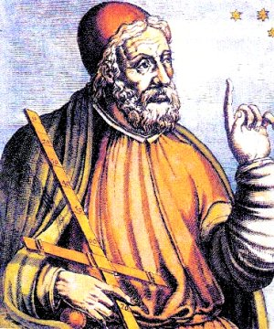
Ptolemy
Claudius Ptolemy was a first and second century CE, philosopher and scientist, who produced a number of writings on a wide range of topics. He was born in Egypt in approximately 85, and may have lived until 165. Early in his life he became a Roman citizen, but researchers show he conducted most of his work and writing in Alexandria, Egypt.
Ptolemy wrote several main works. His most well known tract today is the Almagest, which is a discussion of how the solar system works. Ptolemy posited a geocentric model of the earth, where the planets and sun revolved around the earth. Though this model was naturally discarded, one point of interest in the work was his assumption that the earth was spherical.
Ptolemy derived his work Almagest from the work of Hipparchus. Long after his death, scientists like Sir Isaac Newton would accuse Ptolemy of plagiarism, suggesting he could not possibly have formulated his theories of the universe. Plagiarism is a strong term given the time period in which Ptolemy lived. Copying someone’s work and adding one’s own additions was considered acceptable and flattering.
Ptolemy was also interested in geography, which was reflected in his work the Geographia. He attempted to map the known world, and made some guesses at previously unmapped areas. Though his map was one of the best of its time, it clearly was incorrect, as later cartographers discovered.
One of the greatest achievements of Ptolemy was his approximation of pi, which was the closest in his time period. He believed the closest number to pi was the number 3.14166. The beginning of this number, 3.14, tends to be used in early school studies of circumference and diameter of circles, so one can say that Ptolemy was at least partially correct.
Ptolemy also wrote on art and music, particularly the music of the spheres, which one must consider was work based on that of Plato. His most popular work in his time was the Tetrabiblios, a compilation of known thought on astrology. Unlike many of his contemporaries, Ptolemy did not simply believe in astrological reasons for human behavior.
Instead, Ptolemy posited what many students of human behavior would later conclude, that a human behavior was dictated by a number of influences. Place of birth, upbringing, social structure and race might all be considered influential. While the concept of race being a way to indicate behavior is clearly false, the theory that upbringing is an influence was new to the time, and clearly predates modern psychology by almost 1800 years.

