The Ptolemaic Model
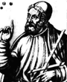
Claudius Ptolemy lived in Rome around 100 AD. His model of the solar system and heavenly sphere was a refinement of previous models developed by Greek astronomers. Ptolemy’s major contribution, however, was that his model could so accurately explain the motions of heavenly bodies, it became the model for understanding the structure of the solar system. It is beyond the scope of this course to discuss all the complex social and historical implications of an Earth-centered versus a Sun-centered model of the solar system. But nearly all the early models, including Ptolemy’s version of the solar system, assumed that the Earth was the center of not only the solar system, but the entire universe.
The Ptolemaic model accounted for the apparent motions of the planets in a very direct way, by assuming that each planet moved on a small sphere or circle, called an epicycle, that moved on a larger sphere or circle, called a deferent. The stars, it was assumed, moved on a celestial sphere around the outside of the planetary spheres.
Ptolemy's fame comes partly from what he figured out, but his influence was largely because he wrote a great summary of everything known about astronomy. Ptolemy insisted that the job of the astronomer was to explain the motions of the wanderers using only uniform circular motion - the kind of motion that most gears and wheels show.
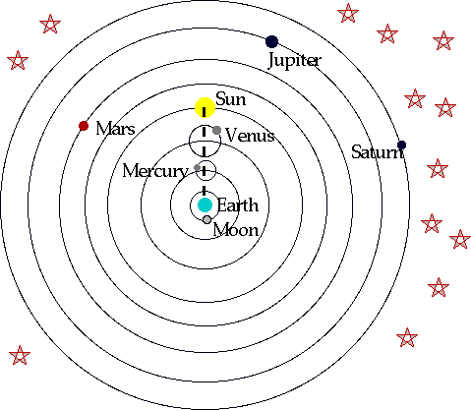
What is a geocentric model?
What are epicycles? Draw them!

