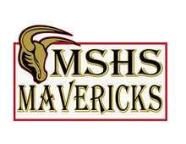
Earth Science: Plate Tectonics / Earthquakes &
Volcanoes Unit Study Guide

Name___________________________________________ Block _________
What is “Fracking”? _______________________________________________________________________

_________________________________________________________________________________________

What are 5 advantages and 5 disadvantages to fracking?

Advantages Disadvantages

- 1)

- 2)

- 3)

- 4)

- 5)

What is a tsunami? __________________________________________________________________

There are 4 ways a tsunami can be created. What are they?
1)

2)

3)

4)

Also, be able to calculate Tsunami distances given the formula!!!

Label the faults with the stress and fault type.
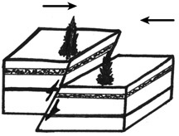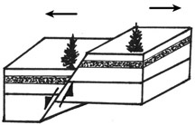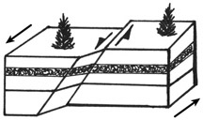
A B C
What are the 2 main ways of building large structures in earthquake zones? Also, what are 2 advantages OR disadvantages to each?
- _______________________________________________________________________________________

- _______________________________________________________________________________________

Earth Science: Plate Tectonics / Earthquakes &
Volcanoes Unit Study Guide

Earthquake Fault Types
Fault Type | Type of Stress & Plate Boundary Where It Is Found | Picture Showing Movement
Reverse
Normal
Strike-Slip

Define, through pictures: Compression Tension Shear

TYPES OF VOLCANOES
Directions: Below, indicate the type of lava associated with each type of volcano, the type of eruption, draw a picture of the volcano and label the lava part and cinder part of each.

Type of Lava: MAFIC (thin, low silica, flows easily) or FELSIC (thick, high silica, flows slowly); or BOTH.
Type of Eruption Quiet or Explosive or BOTH

Tuff Cone/Cinder Cone Composite Shield

Type of Lava _____________________ _____________________ _____________________

Type of Eruption _____________________ _____________________ _____________________

