Earth Science: Note Taking Strategies
To Help You Be Successful!
Cornell Notes

- Divide the paper into three sections.
- Draw a dark horizontal line about 5 or 6 lines from the bottom. Use a heavy magic marker so that it is clear.
- Draw a dark vertical line about 2 inches from the left side of the paper from the top to the horizontal line.

Document
- Write course name, date and topic at the top of each page

Write Notes
- The large box to the right is for writing notes.
- Skip a line between ideas and topics
- Don't use complete sentences. Use abbreviations, whenever possible. Develop a shorthand of your own, such as using & for the word "and"

Review and clarify
- Review the notes as soon as possible after class.
- Pull out main ideas, key points, dates, and people, and write them in the left column.

Summarize
- Write a summary of the main ideas in the bottom section.

Study your notes
- Reread your notes in the right column.
- Spend most of your time studying the ideas in the left column and the summary at the bottom. These are the most important ideas and will probably include most of the information that will be tested.

Example:
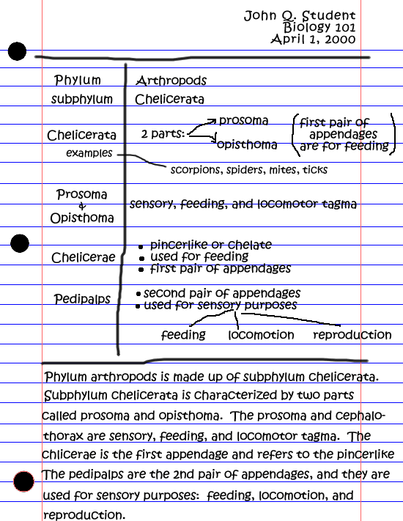
This strategy is based on a strategy presented in Pauk, W. (1997). How to study in college (6th ed). Boston: Houghton Mifflin. Learning Toolbox. Steppingstone Technology Grant, James Madison University,
MSC 1903, Harrisonburg, VA 22807.

