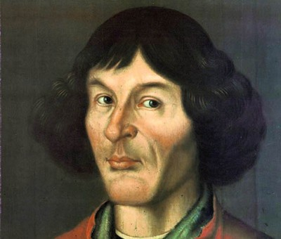
Copernicus
Nicolas Copernicus, or Niclas Kopernik as he was known at birth, was a prominent scientist who revolutionized the way that we look at the universe. Although the concept of a sun-centered or heliocentric solar system might seem obvious to you, when Copernicus suggested it, he met considerable opposition. He also contributed a number of other observations and discussions to the field of astronomy, and it may surprise you to learn that Copernicus actually treated astronomy as a hobby, engaging it in only when he had the time to do so.
Copernicus was born in Poland in 1473, and his father died young, causing him to end up with an uncle who oversaw his extensive education in law and the sciences. In addition to being an astronomer, Copernicus was also a politician, an economist, and a diplomat, and he studied classics, ethics, medicine, and math. He also worked in the Church, making it all the more difficult for him to go against Church doctrine about the nature of the solar system.
Over the course of his life, Copernicus worked as a governor, a translator, a church official, a diplomat, and a military leader. Knowing that he had such a busy life makes it all the more remarkable to consider his career as an astronomer. Many modern astronomers credit Copernicus with taking the first steps in modern astronomy, establishing it as a field of legitimate, interesting, and often very fruitful research. As early as 1514 he was considering the possibility of a heliocentric universe and working on drafts of his De revolutionibus orbium coelestium, a treatise “on the movements of the celestial bodies.”
Alas, Copernicus died in 1543, right before the book was published and distributed. He did not live to see his work totally reshape the way people thought about astronomy and our place in the universe, as his ideas about a heliocentric solar system were met largely with disbelief when he initially posited them. He also did not live to see his work banned by the Catholic Church, an organization he had loyally served throughout his life. Today, people recognize that the Earth does in fact orbit around the sun, and they have also confirmed Copernicus' long held suspicion that there were other solar systems and galaxies in the universe.

