The Copernican Model:
A Sun-Centered Solar System

The Earth-centered Universe of Aristotle and Ptolemy held sway on Western thinking for almost 2000 years. Then, in the 16th century a new idea was proposed by the Polish astronomer Nicolai Copernicus (1473-1543).

The Heliocentric System
In a book called On the Revolutions of the Heavenly Bodies (that was published as Copernicus lay on his deathbed), Copernicus proposed that the Sun, not the Earth, was the center of the Solar System. Such a model is called a heliocentric system. The ordering of the planets known to Copernicus in this new system is illustrated in the following figure, which we recognize as the modern ordering of those planets.
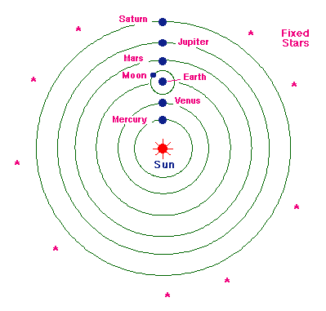
The Copernican Universe

In this new ordering the Earth is just another planet (the third outward from the Sun), and the Moon is in orbit around the Earth, not the Sun. The stars are distant objects that do not revolve around the Sun. Instead, the Earth is assumed to rotate once in 24 hours, causing the stars to appear to revolve around the Earth in the opposite direction.

Retrograde Motion and Varying Brightness of the Planets
The Copernican system by banishing the idea that the Earth was the center of the Solar System, immediately led to a simple explanation of both the varying brightness of the planets and retrograde motion:
- The planets in such a system naturally vary in brightness because they are not always the same distance from the Earth.
- The retrograde motion could be explained in terms of geometry and a faster motion for planets with smaller orbits.
A similar construction can be made to illustrate retrograde motion for a planet inside the orbit of the Earth.

What is Retrograde?

One phenomenon that aincient astronomers had difficulty explaining was the retrograde motion of the planets. Over the course of a single night, a planet will move from East to West across the sky, like any other celestial object near the ecliptic.

If observed from one night to the next, however, a planet appears to move from West to East against the background stars most of the time. Occasionally, however, the planet's motion will appear to reverse direction, and the planet will, for a short time, move from East to West against the background constellations. Take Mercury for instance. Its orbit is inside of Earths. When Mercury passes between Earth and the Sun, it appear to move from East to West from our vantage point. But when the Sun is between Mercury and Earth, Mercury appears to retrograde, or move in reverse, because it looks like it’s going West to East.

Copernicus and the Need for Epicycles
There is a common misconception that the Copernican model did away with the need for epicycles. This is not true, because Copernicus was able to rid himself of the long-held notion that the Earth was the center of the Solar system, but he did not question the assumption of uniform circular motion. Thus, in the Copernican model the Sun was at the center, but the planets still executed uniform circular motion about it. As we shall see later, the orbits of the planets are not circles, they are actually ellipses. As a consequence, the Copernican model, with it assumption of uniform circular motion, still could not explain all the details of planetary motion on the celestial sphere without epicycles. The difference was that the Copernican system required many fewer epicycles than the Ptolemaic system because it moved the Sun to the center.

Draw the Heliocentric Model
Write what Heliocentric means
What is retrograde? Do a demonstration for the class!

