Geoscience
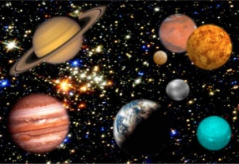
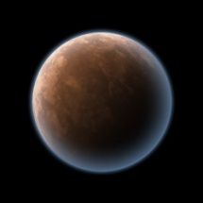
Astronomy Project: Planet Colonization
DUE: Wednesday, November 2nd

This project combines critical thinking, math, art, key concepts in astronomy, & planetary life knowledge. It will challenge you to not only think about the extreme challenges of colonizing distant planets, but also challenge you to create an effective video that communicates your research.

My Planet: ___________________________________________________________________
Animoto Website: www.animoto.com

Directions:
- The research for this project is divided into 4 parts:
  - Planet Composition/Life Possibility
  - Space Vehicle Creation
  - Food/Supply/People Transport
  - House Building/Sustainability

- Once you have completed this portion, you will create an “animoto”. ALL OF THE INFORMATION YOU RESEARCH MUST APPEAR IN YOUR ANIMOTO! Time will be spent in class to setup a free account and give you a tour of the possibilities!

Part 1: Planet Composition
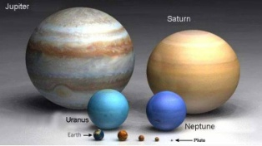
- You will research your assigned Rocky planet. The following information MUST be included in your Animoto::
  - The composition of the atmosphere, surface, and core.
  - Could there be life on the planet? Is it sustainable for life?
  - Why or why not?

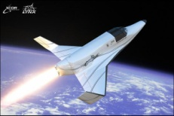
Part 2: Space Vehicle Creation
- Create a space vehicle that will take people, supplies, and food to your assigned planet. The following information MUST be included in your Animoto:
  - A picture of your space vehicle
    - Picture needs to show the passenger compartment, where supplies are stored, the engines, and where food is stored. (Your vehicle MUST make scientific sense!!!... so, don’t build a space boat that will fly to a Rocky planet with no liquid water…)
    - Part of your grade is creativity and whether your vehicle makes scientific sense
    - THE PICTURE MUST BE YOUR OWN!!! IT EITHER NEEDS TO BE HAND-DRAWN OR CREATED BY YOU ON THE COMPUTER.
  - A slide which describes the material used on the outside of your vehicle. It MUST be based in reality! There are new materials being tested that can withstand temperatures up to 3,800 degrees… maybe you could use one of these!
  - You need to have a page which calculates:
    - The distance from Earth to your planet
    - How long it will take your vehicle to get to the planet if your vehicle was going 17,320mph (Speed of Space Shuttle once in orbit)

Part 3: Food/Supply/People Transport
  - What food will you be taking? Why?
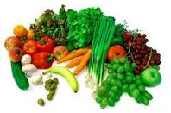
  - You can research the food NASA uses for the International Space Station and for Space Shuttle flights.
  - How much will your passengers be eating and drinking each day of the journey?
  - IT MUST MAKE SENSE! If it takes your vehicle 115 days to reach your planet… you need to have food that can last 230 days since you are only getting food from Earth!
  - What about water? How much does water weigh? How much does the average person drink each day?
  - Keep in mind, your vehicle will be limited to carrying 100,000 pounds of supplies, food, and people.

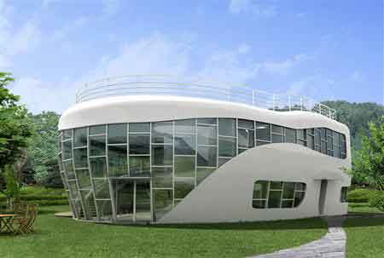
Part 4: House Building/Sustainability
- You need to build 1 house on your planet.
  - How many trips will you need to make to get all of the supplies to your planet?
  - What materials will you use to make the house so it withstands the temperatures on your planet?
  - You can research housing materials and see which ones withstand extreme heat and cold the best.
  - Also, where on the planet will you put your house? Keep in mind your planet is spinning, so it may have to withstand extreme heat and cold!

Once you have researched all 4 parts to this project, the last step is to create a video using Animoto. Think outside the box! Go beyond the basic requirements for full points. Make the video engaging or funny!!! Make us want to watch the video for a 2nd time!!!

Requirements:
- Space Vehicle can only carry 100,000 pounds TOTAL of supplies, people, and food.
- The material you use for your space vehicle MUST come from a reliable source. Print out the article where you learned about this material!
- The material you use for your house MUST come from a reliable source. Print out the article where your learned about this material!

Rubric For Animoto Planet Colonization Project
Requirement for pamphlet or powerpoint | Unsatisfactory | Half-Credit | Exceptional | Point Value
Accurate description of atmosphere, surface, and core | Not included | Included, but not accurate, or accurate but not all included | Included, accurate | ____/5
Life sustainability on planet. Why or why not possible? | Not included | Included, but not properly completed | Included, accurate | ____/5
Space vehicle creation | Not included | Picture is labeled and includes most required parts | Picture is labeled, accurate, and includes all labeled parts | ____/30
Space vehicle calculation | Not included | Distance and time calculated, but not accurate | Calculations complete and accurate | ____/5
Food/water description and calculation | Not included | Included, but not properly described, or does not make scientific sense | Included, properly described, makes scientific sense | ____/15
House materials calculation, description, and placement of house | Not included | Included, but does not mention either transportation on or off planet | Complete | ____/20
Animoto Creativity | Basic animoto, not all information included | Basic animoto, all required information included | Extremely creative, goes above and beyond, extremely engaging video | ____/20

Total Points: _____/100

