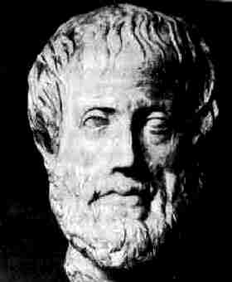
Aristotle
Aristotle is often touted as one of the founding fathers of science. Trained by the great philosopher Plato, Aristotle built a school he called the Lyceum at Athens. He delved into almost all dimensions of knowledge, including philosophy, science, art, literature, and of course astronomy.
Aristotle's father was Nicomachus, a doctor who lived near Macedon, in the north of Greece. So unlike Socrates and Plato, Aristotle was not originally from Athens. He was not from a rich family like Plato, though his father was not poor either.
When Aristotle was a young man, about 350 BC, he went to study at Plato's Academy. Plato was already pretty old then. Aristotle did very well at the Academy. But he never got to be among its leaders, and when Plato died, the leaders chose someone else instead of Aristotle to lead the Academy. Probably Aristotle was pretty upset about this.
Soon afterwards, Aristotle left Athens and went to Macedon to be the tutor of the young prince Alexander, who grew up to be Alexander the Great. As far as we can tell, Alexander was not much interested in learning anything from Aristotle, but they did become friends.
When Alexander grew up and became king, Aristotle went back to Athens and opened his own school there, the Lyceum (lie-SAY-um), in competition with Plato's Academy. Both schools were successful for hundreds of years.
Aristotle was more interested in science than Socrates or Plato, maybe because his father was a doctor. He wanted to use Socrates' logical methods to figure out how the real world worked; therefore Aristotle is really the father of today's scientific method. Aristotle was especially interested in biology, in classifying plants and animals in a way that would make sense. This is part of the Greek impulse to make order out of chaos: to take the chaotic natural world and impose a man-made order on it.
When Alexander the Great was traveling all over Western Asia, he had his messengers bring strange plants back to Aristotle for his studies. Aristotle also made efforts to create order in peoples' governments. He created a classification system of monarchies, oligarchies, tyrannies, democracies and republics which we still use today.
When Alexander died in 323 BC, though, there were revolts against Macedonian rule in Athens. People accused Aristotle of being secretly on the side of the Macedonians (and maybe he was; he was certainly, like Plato, no democrat). He left town quickly, and spent the last years of his life back in the north again where he had been born.

