The Universe of Aristotle
Although Aristotle was not a scientist, it is important to note that he did point out that the Earth had to be sphere since its shadow was always circular.

Aristotle's Spheres
The following figure illustrates the ordering of the spheres to which the Sun, Moon, and visible planets were attached. Aristotle believed in a “geocentric” model, where Earth was at the center of the Solar System. All other objects orbited Earth.
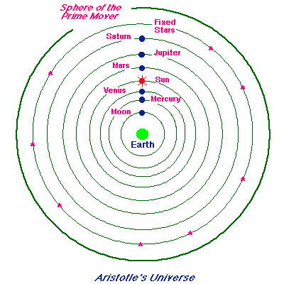
By adjusting the velocities of these concentric spheres, many features of planetary motion could be explained. However, the troubling observations of varying planetary brightness and retrograde motion could not be accommodated: the spheres moved with constant angular velocity, and the objects attached to them were always the same distance from the earth because they moved on spheres with the earth at the center.
Draw the Geocentric Model
Write what Geocentric means

