September 11th, 2001 Remember: What if the weather was different?

Brian Neudorff @ 2:16 am September 11th, 2006
It’s been five year since that terrible and tragic day, but it feels like yesterday. The images from the time I woke up to the time I went to bed stay with me. I was in Bismarck, North Dakota working for KFYR-TV as their weekend meteorologist and weekday reporter. Tuesday was my day off and Trisha, who is now my wife, called and woke me up and asked “How close does your dad work to the World Trade Center” She seemed frantic and I was kind of groggy so I asked why? “A plane has hit the twin towers,” My dad doesn’t work that close to TWC, but I started to remember about a trip they were supposed to take overseas, and I remembered it was that day they were to leave. I went to look for the iternerary and found that they weren’t scheduled to leave until later that night.
It was still still scary because I knew they both were in New York and as I watched all this take place, I, like so many people with family and friends in Manhattan, tried to call in. I will never forget the recorded message I received. “Due to a Tornado in the area we cannot connect your call”… yes that was one of the few times I was able to get through on some line into New York City, but the rest of the time it was busy.
I was able to reach my grandmother in Indiana and she had heard from them and told me they were ok. Once I got to talk to them I was even more scared at what could have been. My step-mother told me that it wasn’t unusual for my dad to have to go to the WTC and do business with the Port Authority. Luckily he didn’t have to go that day. I feel very lucky and very blessed, but sad for all those other families that lost loved ones on that day. For the rest of the day I was calling family and friends and just watching all this not sure what was going to happen if this was just the beginning of something even worst.
The hardest part of September 11th was being all alone. I was in Bismarck with out family. I didn’t have Trisha, my twin sons, who were only 5 months old, and the rest of my family. Everyone was in Indiana. So later that night I went to T.G.I Friday’s with our weekend sports anchor to just sit talk and reflect. We were like the only people there. That was so strange and eerie.
WEATHER ON 9/11
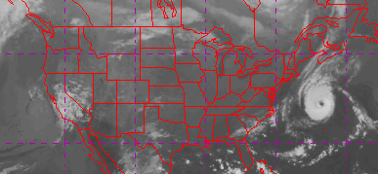
The above image is an infrared satellite image from the morning of September 11th. With the exception of the HUGE Hurricane Erin out in the Atlantic the weather for most of the United States was quite calm. Here is a visible satellite image of Hurricane Erin and in the upper left hand corner of the image you can see a zoomed in portion of New York and the dust being picked up on Satellite. I also found a quicktime movie of a visible satellite loop from the morning of 9/11 and you can see the debris cloud from the fall of the towers.
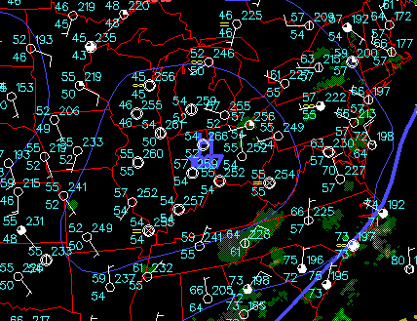
(Click for a national view of the surface map)
The reason for the nice weather across the country was all due to a very strong high pressure system located over Indiana and Ohio. It was also a very nice and bright day as far west as the Dakotas. This makes me wonder “What if?” What if the there was a storm system in the northeast and there were flight delays, or just a low cloud deck over the city of Manhattan so the tops of the WTC would have been covered in clouds instead of visible. Could it have changed things entirely? Again these are just what if’s and it doesn’t and can’t change the past.
As a meteorologist, this is the first time in five years, that I really looked at what the weather was like all over the country. I did this because I just thought it was interesting.

